Creating your own Game Graphics

We need to create 2 images for our ping pong game. Below are examples of what you can make them look like, but you need to make your own using Fireworks or a similar program and using the following pixel sizes (remember you will need to save these files as .png files):

The ball (save this file as ball.png)
20x20

The table (save this file as table.png)
868x626

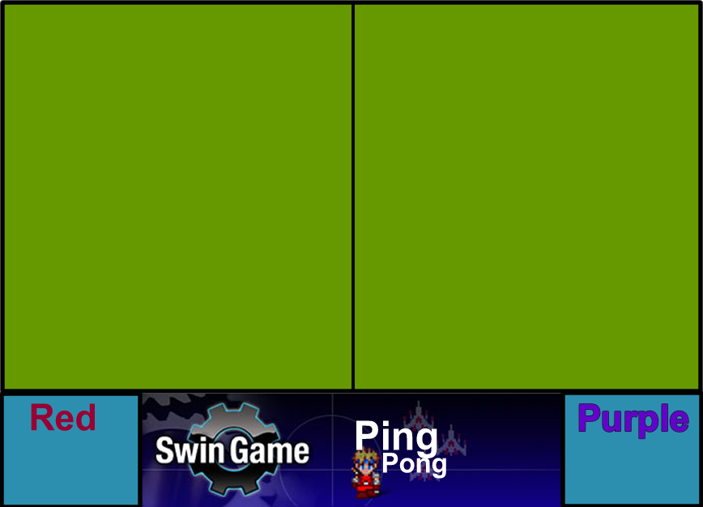
868

487
626

Here is where the scores will go (174 wide)

Make sure your table is of the same dimensions as described above otherwise it will become complicated when we try to code it.

Once you have finished these 2 graphics save them so you can easily find them when we want to import them into our game.

